Storyboard
Course CJE3444, Section 0W89 – Crime Prevention
Dr. Kimberly Kampe

Flowcharts
A flowchart is a diagram that is meant to depict and document a process. It is then presented in a diagram that is clear and easily understood. The following flowchart will storyboard the navigation of the course CJE3444, section 0W89, Crime Prevention, to be taught online, through Webcourses, in the Fall of 2021. Although the content may change prior to the beginning of the course, this flowchart illustrates the course as it is currently planned.
Course Home
1000

Syllabus
1100
Overview
1200
Content Modules
2000-16000

Module 2
3100
Module1
2100

Journal Articles
Module 2 Ppt.
Chapter 2
Chapter 1
Module 1 Ppt.

Discussion
Group Sign-up
Syllabus Quiz
Module 4
5100
Module 3
4100

Module 3 Ppt.
Chapter 3
Journal Articles
Module 4 Ppt.
Chapter 4
Journal Articles

Discussion

Discussion
CPTED Assign.

Exam 1
Discussion
Discussion
Module 6 7100
Journal Articles
Module 6 Ppt.
Chapter 6
Module 5
6100
Exam 1 Review
Module 5 Ppt.
Chapter 5
Discussion
Module 9 Ppt.
Chapter 9
Module 9 10100
Discussion
Module 8 9100
Journal Articles
Module 8 Ppt.
Chapter 8
Journal Articles
Group Project
Discussion
Module 7 8100
Journal Articles
Module 7 Ppt.
Chapter 7
Exam 2
Discussion
Module 11 12100
Exam 1 Review
Module 11 Ppt.
Chapter 11
Discussion
Module 10 11100
Video
Module 10 Ppt.
Chapter 10
Group Project
Discussion
Module 13 14100
Journal Articles
Module 13 Ppt.
Chapter 13
Discussion
Group Project
Module 12 Ppt.
Module 12 13100
Journal Articles
Chapter 12
Final Exam
Discussion
Module 15 16100
Final Review
Module 15 Ppt.
Chapter 17
Chapter 16
Chapter 15
Group Project
Discussion
Module 14 15100
Journal Articles
Module 14 Ppt.
Chapter 14
Storyboards
A storyboard is tool that helps designers organize content into a sequence to visualize the outcome of the final product. A storyboard breaks down the content presentation into individual panels which illustrate the course’s order, navigation, or other pertinent details step-by-step. The storyboard presented is for my Crime Prevention course, CJE3444 section 0W89. This storyboard will be a representation of the flowchart shown above.

Course
CJE3444, section 0W89 – Crime Prevention

Instructor
Dr. Kimberly Kampe

Activity Code Key
CH = Course Home
M = Module
S = Student Activity
A = Assessment

Course Objectives
After taking this course, students should be able to perform the following tasks:
- Discuss the reasons for reported levels of fear of crime.
- Compare primary, secondary, and tertiary crime prevention.
- Assess crime prevention approaches and their goals.
- Recognize the physical environment and crime.
- Explain neighborhood crime prevention.
- Evaluate the mass media and crime prevention connection.
- Define developmental crime prevention.
- Understand crime displacement and diffusion.
- Define and discuss general deterrence.
- Analyze prediction and crime prevention.
- Define situational prevention.
- Describe community policing and crime prevention.
- Establish the connection between drugs, crime, and crime prevention.
- Appraise schools and their approaches to crime prevention.
- Discuss different forms of tertiary crime prevention and their effectiveness.

Course Outline
Module 1 – Crime and the Fear of Crime
Module 2 – Crime Prevention
Module 3 – Evaluation and Crime Prevention
Module 4 – The Physical Environment and Crime
Module 5 – Neighborhood Crime Prevention
Module 6 – Displacement and Diffusion
Module 7 – The Mass Media and Crime Prevention
Module 8 – Developmental Crime Prevention
Module 9 – General Deterrence
Module 10 – Prediction for Secondary Prevention
Module 11 – Situational Crime Prevention
Module 12 – Partnerships for Crime Prevention
Module 13 – Drugs, Crime, and Crime Prevention
Module 14 – The School and Crime Prevention
Module 15 – Specific Deterrence and Incapacitation
Module 16 – Some Closing Thoughts on Crime Prevention and the Future

Course Home – Welcome

Student Activities
CH1S1 Welcome.
CH1S2 Review Course Syllabus.
CH1S3 Review Crime Prevention Overview PowerPoint

Type | # | Resource | Information
Student Activity | 1 | Welcome | Explore and become acquainted with Webcourses and the layout of thee course.
 | 2 | Course Syllabus | Informational document.  Students will have a text version outlining all of the course protocols and expectations that they should review.
 | 3 | Crime Prevention Overview PowerPoint | Students will be asked to review the Crime Prevention Overview PowerPoint which will acquaint them with terminology and concepts that will be used throughout the course.

Project Title: CJE3444  Page Title: Course Home  File Name: CP_CourseHome_Content (folder)  Date: 8/23/2021 – 8/29/2021  Frame #: 1000 |  | Script:  Syllabus document  Crime Prevention Overview PowerPoint
Links:  From Course Home: Syllabus – 1100  Overview – 1200 | Screen Description:  Links to Syllabus
Screen Layout:
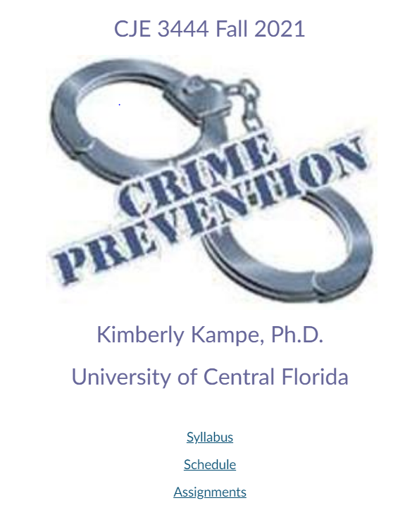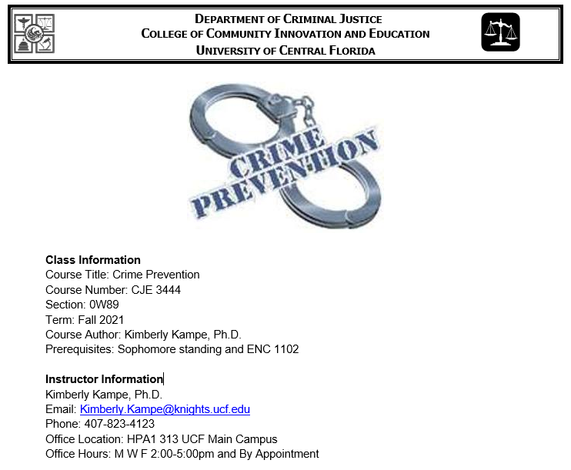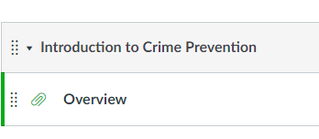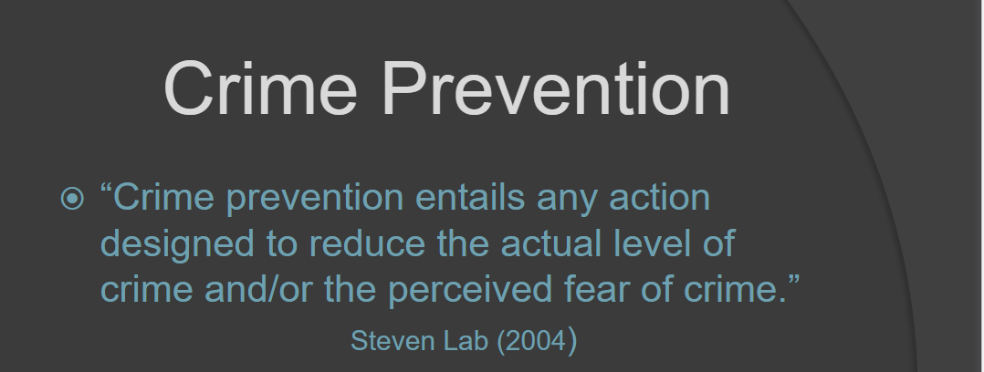
Background:  Color Schemes: Microsoft Word Default  Text Attributes:  Subheading: N/A  Body: Arial | Media:  Audio: Narration by Kampe (2021).  Video: TBD  Animated Gifs: N/A  Graphics: http://3.bp.blogspot.com/-U5Kwiywdg3w/UNCZpYr3vPI/AAAAAAAAEn8/S97SpnrJFjY/s320/crimeprevention.png.
Developer’s Notes: Linked text document and PowerPoint

Module 1 –Crime and the Fear of Crime

Course Objective
The student will be able to perform the following tasks:
- Discuss the reasons for reported levels of fear of crime.

Module 1 Objectives
The student will be able to:
- Define fear of crime.
- Discuss how fear of crime manifests.
- Discuss the levels of societal fear of crime.

Student Activities
M1S1 Lab text, Chapter 1 (Crime and the Fear of Crime).
M1S2 Module 1 PowerPoint (Crime and the Fear of Crime).

Assessment Activities
M1A1 Complete the syllabus quiz in Webcourses under Module 1 assignments.
M1A2 Sign up for a group presentation in Webcourses under Module 1 assignments.

Type | # | Resource | Information
Student Activity | 1 | Lab textbook | Students will be asked to read Chapter 1 (Crime and the Fear of Crime) of their textbook.  This chapter provides students with information about how crime and fear have changed over time and how they still provide the basis for ongoing calls for crime prevention.
 | 2 | Module 1 PowerPoint | Students will be asked to review Chapter 1 PowerPoint (Crime and the Fear of Crime).  This will provide students with a review of the textbook chapter and will point out the most pertinent information from the chapter.
Assessment | 1 | Syllabus Quiz | Complete the syllabus quiz in Module 1.  In order to document that students began this course, they should complete the participation activity by the end of the first week of classes or as soon as possible after adding the course. Failure to do so may result in a delay in the disbursement of financial aid and a zero on the assignment.  This quiz will demonstrate that the student has read and understood the syllabus, which will ensure that students know what will be required of them throughout the course and what protocols they will be expected to follow.
 | 2 | Group presentation sign-up | Students will sign up for the group project and presentation that is of the most interest to them by adding their name to a list within Module 1 of Webcourses.

Project Title: CJE3444  Page Title: Module 1  File Name: CP_Module1_Content (folder)  Date: 8/23/2021 – 8/29/2021  Frame #: 2000 |  | Script:  Module 1: Crime and the Fear of Crime – PowerPoint  Syllabus Quiz – Link  Group Presentation Sign-up – Link
Links:  From Course Home: Module 1 – 2100 | Screen Description:  Links to Module 1
Screen Layout:

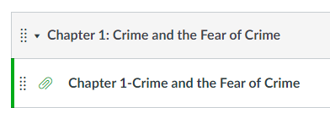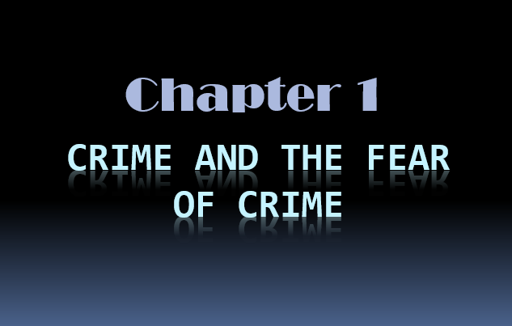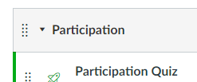

Background:  Color Schemes: Microsoft PowerPoint Metro  Text Attributes: Shadow  Subheading: Microsoft PowerPoint Broadway  Body: Microsoft PowerPoint Consolas (Headings) | Media:  Audio: Narration by Kampe (2021).  Video: TBD  Animated Gifs: TBD  Graphics: TBD
Developer’s Notes: Linked PowerPoint and quiz assignment

Module 2 – Crime Prevention

Course Objective
The student will be able to perform the following tasks:
- Compare primary, secondary, and tertiary crime prevention.

Module 2 Objectives
The student will be able to:
- Define crime prevention.
- Discuss the differences between crime control and crime prevention.
- Discuss other crime prevention models.

Student Activities
M2S1 Lab text, Chapter 2 (Crime Prevention).
M2S2 Module 2 PowerPoint (Crime Prevention).
M2S3 Journal articles.

Assessment Activities
M2A1 Complete the Module 2 Discussion assignment.

Type | # | Resource | Information
Student Activity | 1 | Lab textbook | Students will be asked to read Chapter 2 (Crime Prevention) of their textbook.  This chapter provides students with a brief history of crime prevention throughout history, a definition of crime prevention and crime control, and the crime prevention model that will be utilized throughout the course.
 | 2 | Module 2 PowerPoint | Students will be asked to review Chapter 2 PowerPoint (Crime Prevention).  This will provide students with a review of the textbook chapter and will point out the most pertinent information from the chapter.
 | 3 | Journal articles | Students will be asked to review the additional peer-reviewed journal articles that are presented in Module 2.  These articles provide students with additional information as it relates to crime prevention, crime control, and other crime prevention models that are used alternatively to the framework that is used for this course.
Assessment | 1 | Discussion | Guiding Topic:  Provide an example of an alternative crime prevention model and discuss whether you think that the model that is used by the Lab text or the model that you have chosen is superior in helping to understand crime prevention and its associated activities.  Alternative Topic:  Discuss a topic in the readings that you found interesting, confusing, or in need of further discussion.  Guidelines:  Students will be expected to participate in weekly discussions with their peers to show engagement with the course material. This will include both a substantial original post in which they will discuss an aspect of the week’s material that they found interesting, confusing, or in need of further explanation as well as two responses to fellow students. These discussions will be completed by Sunday of each week at 11:59pm.

Project Title: CJE3444  Page Title: Module 2  File Name: CP_Module2_Content (folder)  Date: 8/30/2021 – 9/5/2021  Frame #: 3000 |  | Script:  Module 2: Crime Prevention – PowerPoint  Module 2 Discussion – Link
Links:  From Course Home: Module 2 – 3100 | Screen Description:  Links to Module 2
Screen Layout:
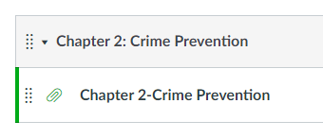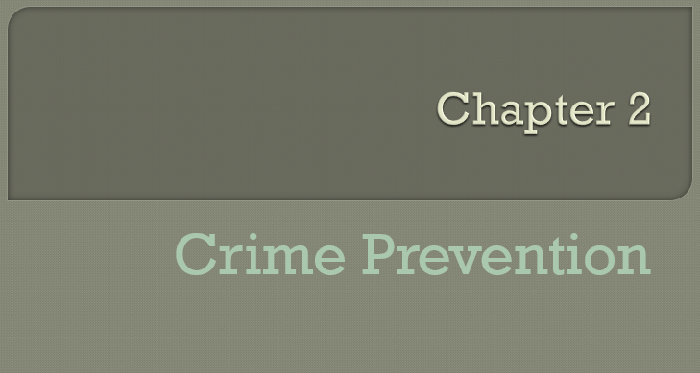
Background:  Color Schemes: Microsoft PowerPoint Foundry  Text Attributes: N/A  Subheading: Microsoft PowerPoint Rockwell (Headings)  Body: Microsoft PowerPoint Rockwell (Body) | Media:  Audio: Narration by Kampe (2021).  Video: TBD  Animated Gifs: TBD  Graphics: TBD
Developer’s Notes: Linked PowerPoint

Module 3 – Evaluation and Crime Prevention

Course Objective
The student will be able to perform the following tasks:
- Assess crime prevention approaches and their goals.

Module 3 Objectives
The student will be able to:
- Distinguish differences between various forms of crime prevention.
- Explain what is meant by the “gold standard” in evaluation.
- Discuss the inherent concerns with relying on only one methodological standard for evaluation.

Student Activities
M3S1 Lab text, Chapter 3 (Evaluation and Crime Prevention).
M3S2 Module 3 PowerPoint (Evaluation and Crime Prevention).
M3S3 Journal articles.

Assessment Activities
M3A1 Complete the Module 3 Discussion assignment.

Type | # | Resource | Information
Student Activity | 1 | Lab textbook | Students will be asked to read Chapter 3 (Evaluation and Crime Prevention) of their textbook.  This chapter provides students with a discussion of the different forms of crime prevention evaluation and the theoretical and measurement problems that are often associated with evaluations. It will also lay the foundation for an understanding of the importance of crime prevention evaluation.
 | 2 | Module 3 PowerPoint | Students will be asked to review Chapter 3 PowerPoint (Evaluation and Crime Prevention).  This will provide students with a review of the textbook chapter and will point out the most pertinent information from the chapter.
 | 3 | Journal articles | Students will be asked to review the additional peer-reviewed journal articles that are presented in Module 3.  These articles provide students with additional information as it relates to different types of crime prevention evaluations and examples of crime prevention evaluations that have been conducted.
Assessment | 1 | Discussion | Guiding Topic:  Choose the form of evaluation that you feel is the most effective and discuss the strengths and weaknesses of the chosen evaluation form. Provide an example of a crime prevention effort that has been evaluated using your chosen method and describe the evaluation and its findings.  Alternative Topic:  Discuss a topic in the readings that you found interesting, confusing, or in need of further discussion.  Guidelines:  Students will be expected to participate in weekly discussions with their peers to show engagement with the course material. This will include both a substantial original post in which they will discuss an aspect of the week’s material that they found interesting, confusing, or in need of further explanation as well as two responses to fellow students. These discussions will be completed by Sunday of each week at 11:59pm.

Project Title: CJE3444  Page Title: Module 3  File Name: CP_Module3_Content (folder)  Date: 9/6/2021 – 9/12/2021  Frame #: 4000 |  | Script:  Module 3: Evaluation and Crime Prevention – PowerPoint  Module 3 Additional Readings – Links  Module 3 Discussion – Link
Links:  From Course Home: Module 3 – 4100 | Screen Description:  Links to Module 3
Screen Layout:
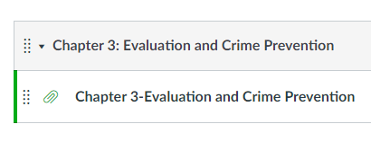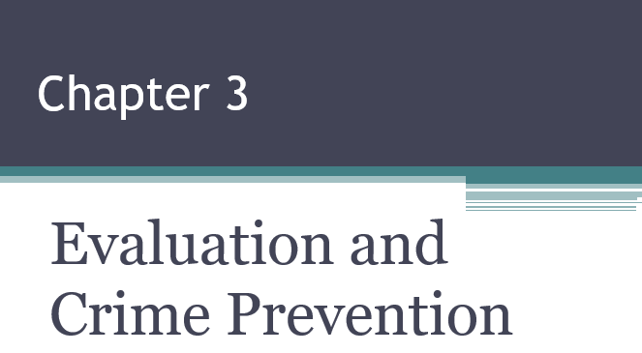
Background:  Color Schemes: Microsoft PowerPoint Urban  Text Attributes: N/A  Subheading: Microsoft PowerPoint Trebuchet MS (Headings)  Body: Microsoft PowerPoint Georgia (Body) | Media:  Audio: Narration by Kampe (2021).  Video: TBD  Animated Gifs: TBD  Graphics: TBD
Developer’s Notes: Linked PowerPoint

Module 4 – The Physical Environment and Crime

Course Objective
The student will be able to perform the following tasks:
- Recognize the physical environment and crime.

Module 4 Objectives
The student will be able to:
- Define CPTED.
- List and define Newman’s elements of defensible space.
- Discuss neighborhood-wide environmental design programs and their impact on crime and fear of crime.

Student Activities
M4S1 Lab text, Chapter 4 (The Physical Environment and Crime).
M4S2 Module 4 PowerPoint (The Physical Environment and Crime).
M4S3 Journal articles.

Assessment Activities
M4A1 Complete the Module 4 Discussion assignment.
M4A2 Complete Self-observation and CPTED assignment.

Type | # | Resource | Information
Student Activity | 1 | Lab textbook | Students will be asked to read Chapter 4 (The Physical Environment and Crime) of their textbook.  This chapter introduces and explains various physical design approaches to crime prevention, examines the impact of these design features on crimes, and assesses the effectiveness of these features.
 | 2 | Module 4 PowerPoint | Students will be asked to review Chapter 4 (The Physical Environment and Crime).  This will provide students with a review of the textbook chapter and will point out the most pertinent information from the chapter.
 | 3 | Journal articles | Students will be asked to find and review any additional peer-reviewed journal articles that they feel relate to the information presented in Module 4.
Assessment | 1 | Discussion | Guiding Topic:  Discuss a neighborhood-wide environmental design program and its impact on crime and fear of crime.  Alternative Topic:  Discuss a topic in the readings that you found interesting, confusing, or in need of further discussion.  Guidelines:  Students will be expected to participate in weekly discussions with their peers to show engagement with the course material. This will include both a substantial original post in which they will discuss an aspect of the week’s material that they found interesting, confusing, or in need of further explanation as well as two responses to fellow students. These discussions will be completed by Sunday of each week at 11:59pm.
 | 2 | Self-observation and CPTED Paper | Assignment to be submitted under the “Assignments” link in Webcourses.  Guidelines:  Spend a day observing yourself. When engaging in this exercise, you should try to detach yourself as if you were a consultant who was hired to watch you. As you observe, include details from in the morning when you wake up until late night when you go to bed. For example, did you keep your doors locked? Did you take the same route to work? Did you stop at the ATM? If so, when?  Choose the place where you spent the most time, such as your place of residence, your workplace, or somewhere that you spent recreational time. Carefully evaluate the location, using CPTED guidelines. Examine how the location compares to CPTED techniques for this land use. What might be done to improve this setting? Are there any liability concerns that seem apparent?  Prepare a 3-5 page summary of your findings. Include research from scholarly sources that reinforce your conclusions.

Project Title: CJE3444  Page Title: Module 4  File Name: CP_Module4_Content (folder)  Date: 9/13/2021 – 9/19/2021  Frame #: 5000 |  | Script:  Module 4: The Physical Environment and Crime – PowerPoint  Module 4 Discussion – Link  Self-observation and CPTED – Submission link
Links:  From Course Home: Module 4 – 5100 | Screen Description:  Links to Module 4
Screen Layout:
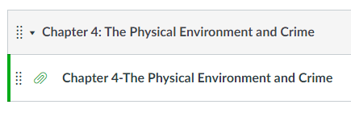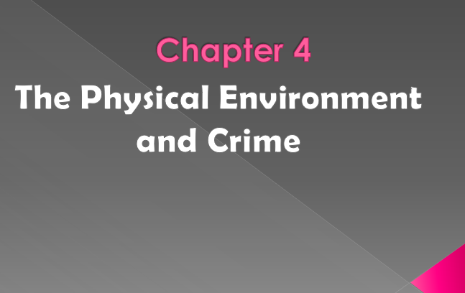
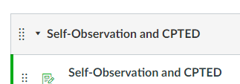

Background:  Color Schemes: Microsoft PowerPoint Verve  Text Attributes: N/A  Subheading: Microsoft PowerPoint Century Gothic (Headings)  Body: Microsoft PowerPoint Berlin Sans FB Demi | Media:  Audio: Narration by Kampe (2021).  Video: TBD  Animated Gifs: TBD  Graphics: TBD
Developer’s Notes: Linked PowerPoint and assignment
Module 5 – Neighborhood Crime Prevention

Course Objective
The student will be able to perform the following tasks:
- Explain neighborhood crime prevention.

Module 5 Objectives
The student will be able to:
- Discuss citizen patrols and their crime prevention activities.
- Discuss the impact of neighborhood crime prevention on crime and fear of crime.
- Identify and discuss who is most likely to participate in neighborhood crime prevention.

Student Activities
M5S1 Lab text, Chapter 5 (Neighborhood Crime Prevention).
M5S2 Module 5 PowerPoint (Neighborhood Crime Prevention).
M5S3 Exam 1 Review.

Assessment Activities
M5A1 Complete the Module 5 Discussion assignment.
M5A2 Complete Exam 1.

Type | # | Resource | Information
Student Activity | 1 | Lab textbook | Students will be asked to read Chapter 5 (Neighborhood Crime Prevention) of their textbook.  In this chapter, students will learn about the link between the physical design features discussed in Chapter 4 and intervening factors, such as increased social cohesion, on crime and crime prevention.
 | 2 | Module 5 PowerPoint | Students will be asked to review Chapter 5 (Neighborhood Crime Prevention).  This will provide students with a review of the textbook chapter and will point out the most pertinent information from the chapter.
 | 3 | Exam 1 Review | The exam will be based on class notes, assigned course readings, handouts, class assignments, class discussions, and other required course material.  It is the responsibility of the student to be prepared for all exams by reviewing the material from Chapters 1-5.
Assessment | 1 | Discussion | Guiding Topic:  Describe the type of person who is most likely to participate in a neighborhood crime prevention program. How likely are you to participate in a neighborhood crime prevention program if your community were to introduce one?  Alternative Topic:  Discuss a topic in the readings that you found interesting, confusing, or in need of further discussion.  Guidelines:  Students will be expected to participate in weekly discussions with their peers to show engagement with the course material. This will include both a substantial original post in which they will discuss an aspect of the week’s material that they found interesting, confusing, or in need of further explanation as well as two responses to fellow students. These discussions will be completed by Sunday of each week at 11:59pm.
 | 2 | Exam 1 | Exam 1 can be found under the “Exams” tab in Webcourses.  Guidelines:  Exams will be 50 questions in the format of multiple choice and true/false. Students will have 75 minutes from the time that they open the exam to answer all questions and submit their responses. Should a student not complete all 50 questions in the time provided, the exam will automatically be submitted by Webcourses with the answers that have been given by the student. Unanswered questions will be graded as incorrect.  All exams must be taken before the test closing date. No makeup exams will be given without the prior, explicit approval of the instructor or a documented emergency. Should a student miss an exam, it is the responsibility of the student to make arrangements with the instructor to make up that exam.

Project Title: CJE3444  Page Title: Module 5  File Name: CP_Module5_Content (folder)  Date: 9/20/2021 – 9/26/2021  Frame #: 6000 |  | Script:  Module 5: Neighborhood Crime Prevention – PowerPoint  Exam 1 Review – Text document  Module 5 Discussion – Link  Exam 1 – Quiz
Links:  From Course Home: Module 5 – 6100 | Screen Description:  Links to Module 5
Screen Layout:
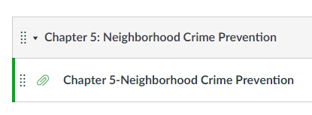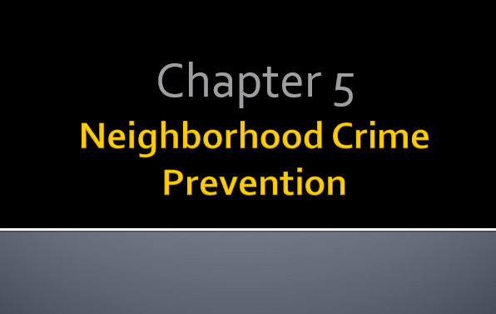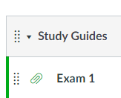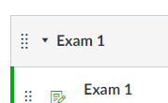

Background:  Color Schemes: Microsoft PowerPoint Module  Text Attributes: N/A  Subheading: Microsoft PowerPoint Corbel (Headings)  Body: Microsoft PowerPoint Corbel (Body) | Media:  Audio: Narration by Kampe (2021).  Video: TBD  Animated Gifs: TBD  Graphics: TBD
Developer’s Notes: Linked PowerPoint, text document, and exam
Module 6 – Displacement and Diffusion

Course Objective
The student will be able to perform the following tasks:
- Discuss developmental prevention.

Module 6 Objectives
The student will be able to:
- Discuss the underlying assumptions of diffusion.
- Explain rational choice theory and its relationship to displacement.
- Explain diffusion of benefits.

Student Activities
M6S1 Lab text, Chapter 6 (Displacement and Diffusion).
M6S2 Module 6 PowerPoint (Displacement and Diffusion).
M6S3 Journal articles.

Assessment Activities
M6A1 Complete the Module 6 Discussion assignment.

Type | # | Resource | Information
Student Activity | 1 | Lab textbook | Students will be asked to read Chapter 6 (Displacement and Diffusion) of their textbook.  This chapter will outline the concepts of crime displacement and diffusion, discuss the potential of offenders to shift their criminogenic activities, and review the literature on displacement and diffusion.
 | 2 | Module 6 PowerPoint | Students will be asked to review Chapter 6 (Displacement and Diffusion).  This will provide students with a review of the textbook chapter and will point out the most pertinent information from the chapter.
 | 3 | Journal articles | Students will be asked to find and review any additional peer-reviewed journal articles that they feel relate to the information presented in Module 6.
Assessment | 1 | Discussion | Guiding Topic:  Find a peer-reviewed article that discusses a crime prevention effort in which diffusion occurred. Discuss the crime prevention effort and why it led to a diffusion of benefits.  Alternative Topic:  Discuss a topic in the readings that you found interesting, confusing, or in need of further discussion.  Guidelines:  Students will be expected to participate in weekly discussions with their peers to show engagement with the course material. This will include both a substantial original post in which they will discuss an aspect of the week’s material that they found interesting, confusing, or in need of further explanation as well as two responses to fellow students. These discussions will be completed by Sunday of each week at 11:59pm.

Project Title: CJE3444  Page Title: Module 6  File Name: CP_Module6_Content (folder)  Date: 9/27/2021 – 10/3/2021  Frame #: 7000 |  | Script:  Module 6: Displacement and Diffusion – PowerPoint  Module 6 Discussion – Link
Links:  From Course Home: Module 6 – 7100 | Screen Description:  Links to Module 6
Screen Layout:
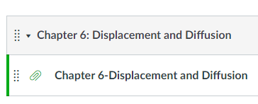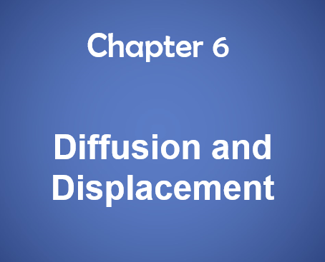

Background:  Color Schemes: Microsoft PowerPoint Office Theme  Text Attributes: N/A  Subheading: Microsoft PowerPoint Berlin Sans FB  Body: Microsoft PowerPoint Andalus | Media:  Audio: Narration by Kampe (2021).  Video: TBD  Animated Gifs: TBD  Graphics: TBD
Developer’s Notes: Linked PowerPoint

Module 7 – The Mass Media and Crime Prevention

Course Objective
The student will be able to perform the following tasks:
- Evaluate the mass media and crime prevention connection.

Module 7 Objectives
The student will be able to:
- Discuss media accounts of crime and how they relate to actual crime.
- Discuss research on whether the media creates crime.
- Define “anticipatory benefit” and discuss its impact.

Student Activities
M7S1 Lab text, Chapter 7 (The Mass Media and Crime Prevention).
M7S2 Module 7 PowerPoint (The Mass Media and Crime Prevention).
M7S3 Journal articles.

Assessment Activities
M7A1 Complete the Module 7 Discussion assignment.
M7A2 Group Media assignment and presentation.

Type | # | Resource | Information
Student Activity | 1 | Lab textbook | Students will be asked to read Chapter 7 (The Mass Media and Crime Prevention) of their textbook.  Students will learn that traditionally research has examined the potential of the media to lead to criminogenic behaviors. However, this chapter will also discuss crime prevention programs that have used the media to induce crime prevention activities.
 | 2 | Module 7 PowerPoint | Students will be asked to review Chapter 7 (The Mass Media and Crime Prevention).  This will provide students with a review of the textbook chapter and will point out the most pertinent information from the chapter.
 | 3 | Journal articles | Students will be asked to find and review any additional peer-reviewed journal articles that they feel relate to the information presented in Module 7.
Assessment | 1 | Discussion | Guiding Topic:  Discuss a program that uses the media to promote and induce crime prevention behaviors. Do you think that the program is effective? If not, what could be done to use the media to make the program stronger?  Alternative Topic:  Discuss a topic in the readings that you found interesting, confusing, or in need of further discussion.  Guidelines:  Students will be expected to participate in weekly discussions with their peers to show engagement with the course material. This will include both a substantial original post in which they will discuss an aspect of the week’s material that they found interesting, confusing, or in need of further explanation as well as two responses to fellow students. These discussions will be completed by Sunday of each week at 11:59pm.
 | 2 | Group Media assignment and presentation | Topic:  Choose a media sample (a movie, an episode of a crime series, an article in the newspaper, etc.) that pertains to criminal justice. Consider what types of messages you received from the media (such as, who were the criminals, how are crimes committed, what are the victims like, etc.). What are the benefits of this form of media? What are the drawbacks? Do you believe that the benefits outweigh the drawbacks? Why or why not? Make all of you considerations with criminal justice in mind. Provide an overall assessment of this type of media as a crime prevention tool.  Guidelines:  Prepare a 10–15-page summary of your findings. Include research from scholarly sources that reinforce your conclusions.  Presentations on this assignment should summarize the findings from your paper as well as the research that you found. Also include a “best practices” section to your presentation that covers what the form of media that you chose should do in order to be a good tool for crime prevention.

Project Title: CJE3444  Page Title: Module 7  File Name: CP_Module7_Content (folder)  Date: 10/4/2021 – 10/10/2021  Frame #: 8000 |  | Script:  Module 7: The Mass Media and Crime Prevention – PowerPoint  Module 7 Discussion – Link  Media Papers and Presentations – Link
Links:  From Course Home: Module 7 – 8100 | Screen Description:  Links to Module 7
Screen Layout:
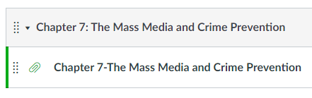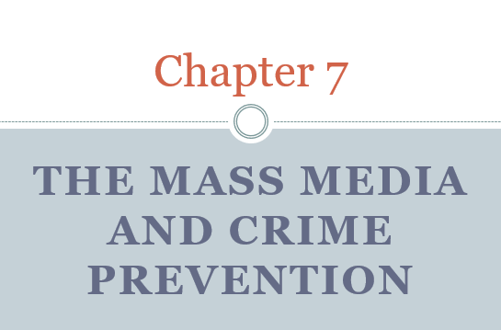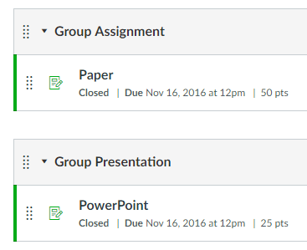

Background:  Color Schemes: Microsoft PowerPoint Civic  Text Attributes: N/A  Subheading: Microsoft PowerPoint Broadway  Body: Microsoft PowerPoint Georgia (Body) | Media:  Audio: Narration by Kampe (2021).  Video: TBD  Animated Gifs: TBD  Graphics: TBD
Developer’s Notes: Linked PowerPoint and group assignment

Module 8 – Developmental Crime Prevention

Course Objective
The student will be able to perform the following tasks:
- Define developmental crime prevention.

Module 8 Objectives
The student will be able to:
- Discuss different models of developmental crime prevention.
- Identify risk factors for delinquency and criminality.
- Discuss the role of risk factors in developmental crime prevention.

Student Activities
M8S1 Lab text, Chapter 8 (Developmental Crime Prevention).
M8S2 Module 8 PowerPoint (Developmental Crime Prevention).
M8S3 Journal articles.

Assessment Activities
M8A1 Complete the Module 8 Discussion assignment.

Type | # | Resource | Information
Student Activity | 1 | Lab textbook | Students will be asked to read Chapter 8 (Developmental Crime Prevention) of their textbook.  This chapter will outline the basic ideas and arguments underlying developmental prevention, discuss risk and protective factors as they relate to developmental prevention, and discuss several developmental programs that have been introduced.
 | 2 | Module 8 PowerPoint | Students will be asked to review Chapter 8 (Developmental Crime Prevention).  This will provide students with a review of the textbook chapter and will point out the most pertinent information from the chapter.
 | 3 | Journal articles | Students will be asked to find and review any additional peer-reviewed journal articles that they feel relate to the information presented in Module 8.
Assessment | 1 | Discussion | Guiding Topic:  How accurate do you think that predictions of based on developmental risk factors are in predicting delinquency/criminality? Use scholarly sources (such as peer-reviewed journals) to support your arguments.  Guidelines:  Students will be expected to participate in weekly discussions with their peers to show engagement with the course material. This will include both a substantial original post in which they will discuss an aspect of the week’s material that they found interesting, confusing, or in need of further explanation as well as two responses to fellow students. These discussions will be completed by Sunday of each week at 11:59pm.

Project Title: CJE3444  Page Title: Module 8  File Name: CP_Module8_Content (folder)  Date: 10/11/2021 – 10/17/2021  Frame #: 9000 |  | Script:  Module 8: Developmental Crime Prevention – PowerPoint  Module 8 Discussion – Link
Links:  From Course Home: Module 8 – 9100 | Screen Description:  Links to Module 8
Screen Layout:
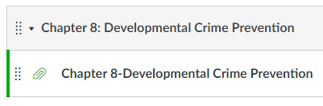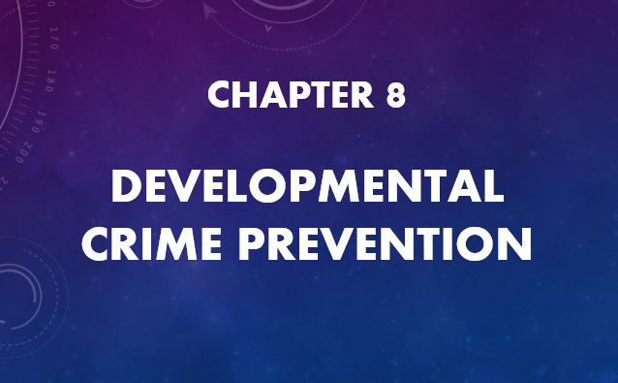

Background:  Color Schemes: Microsoft PowerPoint Celestial  Text Attributes: N/A  Subheading: Microsoft PowerPoint Aharoni  Body: Microsoft PowerPoint Calibri (Body) | Media:  Audio: Narration by Kampe (2021).  Video: TBD  Animated Gifs: TBD  Graphics: TBD
Developer’s Notes: Linked PowerPoint

Module 9 – General Deterrence

Course Objective
The student will be able to perform the following tasks:
- Define and discuss general deterrence.

Module 9 Objectives
The student will be able to:
- Identify two types of general deterrence.
- Discuss the “brutalization effect” of the death penalty.
- Discuss the “experiential effect.”

Student Activities
M9S1 Lab text, Chapter 9 (General Deterrence).
M9S2 Module 9 PowerPoint (General Deterrence).

Assessment Activities
M9A1 Complete the Module 9 Discussion assignment.

Type | # | Resource | Information
Student Activity | 1 | Lab textbook | Students will be asked to read Chapter 9 (General Deterrence) of their textbook.  This chapter will present students with the underlying ideas of deterrence and briefly examines the research on general deterrence (influencing by fear).
 | 2 | Module 9 PowerPoint | Students will be asked to review Chapter 9 (General Deterrence).  This will provide students with a review of the textbook chapter and will point out the most pertinent information from the chapter.
Assessment | 1 | Discussion | Guiding Topic:  Discuss the requirements for deterrence to occur. Which of these do you feel is the most influential to deterring crime and why?  Alternative Topic:  Discuss a topic in the readings that you found interesting, confusing, or in need of further discussion.  Guidelines:  Students will be expected to participate in weekly discussions with their peers to show engagement with the course material. This will include both a substantial original post in which they will discuss an aspect of the week’s material that they found interesting, confusing, or in need of further explanation as well as two responses to fellow students. These discussions will be completed by Sunday of each week at 11:59pm.

Project Title: CJE3444  Page Title: Module 9  File Name: CP_Module9_Content (folder)  Date: 10/18/2021 – 10/24/2021  Frame #: 10000 |  | Script:  Module 9: General Deterrence – PowerPoint  Module 9 Discussion – Link
Links:  From Course Home: Module 9 – 10100 | Screen Description:  Links to Module 9
Screen Layout:

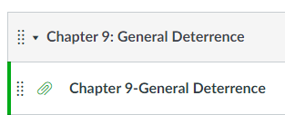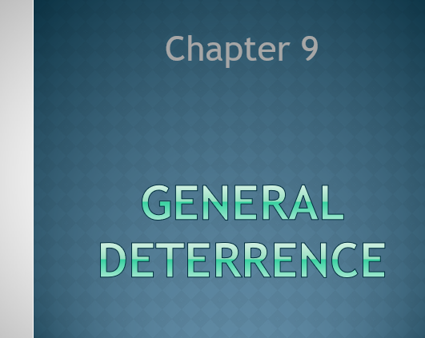

Background:  Color Schemes: Microsoft PowerPoint Opulent  Text Attributes: N/A  Subheading: Microsoft PowerPoint Trebuchet MS (Headings)  Body: Microsoft PowerPoint Calibri (Body) | Media:  Audio: Narration by Kampe (2021).  Video: TBD  Animated Gifs: TBD  Graphics: TBD
Developer’s Notes: Linked PowerPoint

Module 10 – Prediction for Secondary Prevention

Course Objective
The student will be able to perform the following tasks:
- Analyze prediction and crime prevention.

Module 10 Objectives
The student will be able to:
- Identify the key factors involved in making predictions about future criminal behavior.
- Distinguish between false positive and false negative predictions.
- Define and discuss repeat victimization.

Student Activities
M10S1 Lab text, Chapter 10 (Prediction for Secondary Prevention).
M10S2 Module 10 PowerPoint (Prediction for Secondary Prevention).
M10S3 Watch Minority Report.

Assessment Activities
M10A1 Complete the Module 10 Discussion assignment.

Type | # | Resource | Information
Student Activity | 1 | Lab textbook | Students will be asked to read Chapter 10 (Prediction for Secondary Prevention) of their textbook.  In this chapter, students will explore the problem of prediction and identification for prevention purposes. This includes predicting offending behavior, analyzing risk factors for deviance, and identifying places, times, and individual victimization.
 | 2 | Module 10 PowerPoint | Students will be asked to review Chapter 10 (Prediction for Secondary Prevention).  This will provide students with a review of the textbook chapter and will point out the most pertinent information from the chapter.
 | 3 | Minority Report Video | Students will be asked to watch the movie Minority Report.  This movie is about a future where a special police unit is able to arrest murderers before they commit their crimes. However, an officer from that unit is himself accused of a future murder.  This will give students an opportunity to consider the ethical questions surrounding the prediction of future criminal behavior.
Assessment | 1 | Discussion | Guiding Topic:  What do you think are the inherent dangers of making predictions regarding potential criminal behavior? What are the benefits to society of attempting to predict criminogenic behaviors before they occur? How accurate do think predictions of future criminality are?  Alternative Topic:  Discuss a topic in the readings that you found interesting, confusing, or in need of further discussion.  Guidelines:  Students will be expected to participate in weekly discussions with their peers to show engagement with the course material. This will include both a substantial original post in which they will discuss an aspect of the week’s material that they found interesting, confusing, or in need of further explanation as well as two responses to fellow students. These discussions will be completed by Sunday of each week at 11:59pm.

Project Title: CJE3444  Page Title: Module 10  File Name: CP_Module10_Content (folder)  Date: 10/25/2021 – 10/31/2021  Frame #: 11000 |  | Script:  Module 10: Prediction for Secondary Prevention – PowerPoint  Minority Report – Link  Module 10 Discussion – Link
Links:  From Course Home: Module 10 – 11100 | Screen Description:  Links to Module 10
Screen Layout:

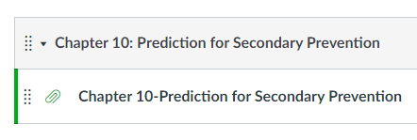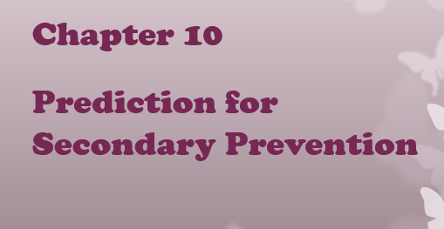

Background:  Color Schemes: Microsoft PowerPoint Spring  Text Attributes: N/A  Subheading: Microsoft PowerPoint Cooper Black  Body: Microsoft PowerPoint Verdana (Body) | Media:  Audio: Narration by Kampe (2021).  Video: https://archive.org/details/MinorityReport  Animated Gifs: TBD  Graphics: TBD
Developer’s Notes: Linked PowerPoint and Movie

Module 11 – Situational Crime Prevention

Course Objective
The student will be able to perform the following tasks:
- Define situational prevention.

Module 11 Objectives
The student will be able to:
- Discuss the theoretical bases for situational prevention.
- Explain the historical changes to the situational typology.
- Provide examples of situational prevention.

Student Activities
M11S1 Lab text, Chapter 11 Situational Crime Prevention).
M11S2 Module 11 PowerPoint (Situational Crime Prevention).
M11S3 Exam 2 Review.

Assessment Activities
M11A1 Complete the Module 11 Discussion assignment.
M11A2 Complete Exam 2.
M11A3 Group Situational Crime Prevention Techniques assignments and presentations.

Type | # | Resource | Information
Student Activity | 1 | Lab textbook | Students will be asked to read Chapter 11 (Situational Crime Prevention) of their textbook.  This chapter outlines the growth of situational crime prevention, discusses the traditional rationales upon which it is based, and provides examples of situational prevention in action.
 | 2 | Module 11 PowerPoint | Students will be asked to review Chapter 11 (Situational Crime Prevention).  This will provide students with a review of the textbook chapter and will point out the most pertinent information from the chapter.
 | 3 | Exam 2 Review | The exam will be based on class notes, assigned course readings, handouts, class assignments, class discussions, and other required course material.  It is the responsibility of the student to be prepared for all exams by reviewing the material from Chapters 6-11.
Assessment | 1 | Discussion | Guiding Topic:  Discuss the evolution of the situational crime prevention typology. Do you feel that the typology, in its current iteration, is complete? Why or why not?  Alternative Topic:  Discuss a topic in the readings that you found interesting, confusing, or in need of further discussion.  Guidelines:  Students will be expected to participate in weekly discussions with their peers to show engagement with the course material. This will include both a substantial original post in which they will discuss an aspect of the week’s material that they found interesting, confusing, or in need of further explanation as well as two responses to fellow students. These discussions will be completed by Sunday of each week at 11:59pm.
 | 2 | Exam 2 | Exam 2 can be found under the “Exams” tab in Webcourses.  Guidelines:  Exams will be 50 questions in the format of multiple choice and true/false. Students will have 75 minutes from the time that they open the exam to answer all questions and submit their responses. Should a student not complete all 50 questions in the time provided, the exam will automatically be submitted by Webcourses with the answers that have been given by the student. Unanswered questions will be graded as incorrect.  All exams must be taken before the test closing date. No makeup exams will be given without the prior, explicit approval of the instructor or a documented emergency. Should a student miss an exam, it is the responsibility of the student to make arrangements with the instructor to make up that exam.
 |  | Group Situational Crime Prevention Techniques assignments and presentations | Topic:  Observe a location for at least 30 minutes. Take notes on what you observe. Following your observation, you should consider what examples of lifestyle perspective may be applied. For example, are their ways that people are acting that might be construed as contributing to possible scenarios that might create opportunities for victimization or are their guardianship issues that are being missed by people? Also consider what are the potential chances for crime that you have seen? Of the twenty-five techniques of situational crime prevention listed in your text in Table 10.2 on page 199, which could or should be applied to improve the area you observed when it comes to vulnerability to crime? What are the costs of implementation (business, structural, aesthetic, etc.)?  Guidelines:  Prepare a 10–15-page summary of your findings. Include research from scholarly sources that reinforce your conclusions.  Presentations on this assignment should summarize the findings from your paper as well as the research that you found. Also include whether or not you feel as though immediate changes should be implemented in light of your findings.

Project Title: CJE3444  Page Title: Module 11  File Name: CP_Module11_Content (folder)  Date: 11/1/2021 – 11/7/2021  Frame #: 12000 |  | Script:  Module 11: Situational Crime Prevention – PowerPoint  Exam 2 Review – Text document  Module 11 Discussion – Link  Exam 2 – Quiz  Situational Crime Prevention Papers and Presentations – Link
Links:  From Course Home: Module 11 – 12100 | Screen Description:  Links to Module 11
Screen Layout:

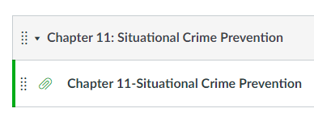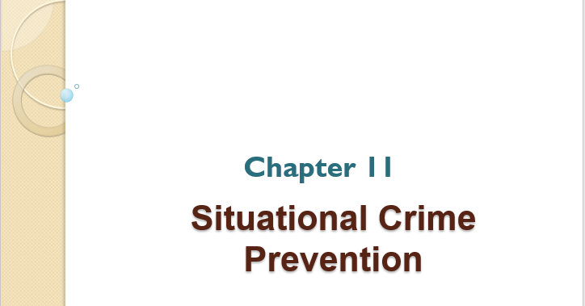
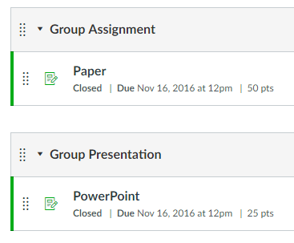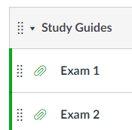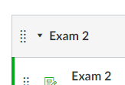

Background:  Color Schemes: Microsoft PowerPoint Solstice  Text Attributes: N/A  Subheading: Microsoft PowerPoint Andalus  Body: Microsoft PowerPoint Gill Sans MT (Body) | Media:  Audio: Narration by Kampe (2021).  Video: TBD  Animated Gifs: TBD  Graphics: TBD
Developer’s Notes: Linked PowerPoint, text document, quiz, and group assignment

Module 12 – Partnerships for Crime Prevention

Course Objective
The student will be able to perform the following tasks:
- Describe community policing and crime prevention.

Module 12 Objectives
The student will be able to:
- Explain SARA and its components.
- Discuss the keys to successful partnerships.
- Discuss civil abatement.

Student Activities
M12S1 Lab text, Chapter 12 (Partnerships for Crime Prevention).
M12S2 Module 12 PowerPoint (Partnerships for Crime Prevention).
M12S3 Journal articles.

Assessment Activities
M12A1 Complete the Module 12 Discussion assignment.
M12A2 Group Crime Prevention Partnerships assignments and presentations.

Type | # | Resource | Information
Student Activity | 1 | Lab textbook | Students will be asked to read Chapter 12 (Partnerships for Crime Prevention) of their textbook.  This chapter outlines the growth of situational crime prevention, discusses the traditional rationales upon which it is based, and provides examples of situational prevention in action.
 | 2 | Module 12 PowerPoint | Students will be asked to review Chapter 12 (Partnerships for Crime Prevention).  This will provide students with a review of the textbook chapter and will point out the most pertinent information from the chapter.
 | 3 | Journal articles | Students will be asked to find and review any additional peer-reviewed journal articles that they feel relate to the information presented in Module 12.
Assessment | 1 | Discussion | Guiding Topic:  Do you think that community policing is effective? Why or why not? Support your findings through scholarly sources (such as peer-reviewed journal articles).  Alternative Topic:  Discuss a topic in the readings that you found interesting, confusing, or in need of further discussion.  Guidelines:  Students will be expected to participate in weekly discussions with their peers to show engagement with the course material. This will include both a substantial original post in which they will discuss an aspect of the week’s material that they found interesting, confusing, or in need of further explanation as well as two responses to fellow students. These discussions will be completed by Sunday of each week at 11:59pm.
 | 2 | Group Crime Prevention Partnerships assignments and presentations | Topic:  Choose a crime prevention partnership from the text and evaluate its effectiveness in crime prevention and/or the reduction of crime. Consider successfulness according to whether or not there is identification of strong leaders and management, agreement on the problem and intervention, recruitment of qualified staff, research of the problem, the building of grass roots support, the identification of adequate funding and resources, provision of good oversight of project implementation, and an evaluation of the efforts.  Guidelines:  Prepare a 10–15-page summary of your findings. Include research from scholarly sources that reinforce your conclusions.  Presentations on this assignment should summarize the findings from your paper as well as the research that you found. Presentations should also include examples of this type of partnership and whether or not they were effective in reducing crime and/or fear of crime.

Project Title: CJE3444  Page Title: Module 12  File Name: CP_Module12_Content (folder)  Date: 11/8/2021 – 11/14/2021  Frame #: 13000 |  | Script:  Module 12: Partnerships for Crime Prevention – PowerPoint  Module 12 Discussion – Link  Crime Prevention Partnerships Papers and Presentations – Link
Links:  From Course Home: Module 12 – 13100 | Screen Description:  Links to Module 12
Screen Layout:

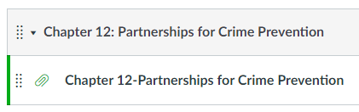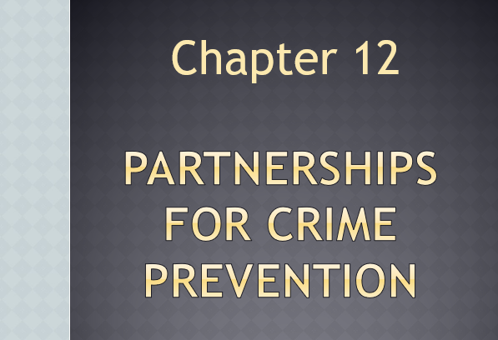

Background:  Color Schemes: Microsoft PowerPoint Opulent  Text Attributes: N/A  Subheading: Microsoft PowerPoint Trebuchet MS (Headings)  Body: Microsoft PowerPoint Berlin Sans FB Demi | Media:  Audio: Narration by Kampe (2021).  Video: TBD  Animated Gifs: TBD  Graphics: TBD
Developer’s Notes: Linked PowerPoint and group assignment

Module 13 – Drugs, Crime, and Crime Prevention

Course Objective
The student will be able to perform the following tasks:
- Establish the connection between drugs, crime, and crime prevention.

Module 13 Objectives
The student will be able to:
- Discuss the psychopharmacological explanation of the drugs-crime connection.
- Identify different forms of drug treatment.
- Discuss education/information/knowledge programs and their impact on drug use.

Student Activities
M13S1 Lab text, Chapter 13 (Drugs, Crime, and Crime Prevention).
M13S2 Module 13 PowerPoint (Drugs, Crime, and Crime Prevention).
M13S3 Journal articles.

Assessment Activities
M13A1 Complete the Module 13 Discussion assignment.
M13A2 Group Drugs-Crime Connection assignments and presentations.

Type | # | Resource | Information
Student Activity | 1 | Lab textbook | Students will be asked to read Chapter 13 (Drugs, Crime, and Crime Prevention) of their textbook.  Students will learn about drug use in the context of crime prevention. Often, it is not the use of the drug itself that is the problem, but the crimes that are associated with its use (such as the sale of narcotics or stealing to obtain funds for obtaining drugs). This chapter will discuss the level of drug use/abuse in society, the connection between drug use and crime, and the effectiveness of various drug use interventions.
 | 2 | Module 13 PowerPoint | Students will be asked to review Chapter 13 (Drugs, Crime, and Crime Prevention).  This will provide students with a review of the textbook chapter and will point out the most pertinent information from the chapter.
 | 3 | Journal articles | Students will be asked to find and review any additional peer-reviewed journal articles that they feel relate to the information presented in Module 13.
Assessment | 1 | Discussion | Guiding Topic:  What impact do law enforcement, treatment, and other preventive approaches have on the level of drug use and related crime?  Alternative Topic:  Discuss a topic in the readings that you found interesting, confusing, or in need of further discussion.  Guidelines:  Students will be expected to participate in weekly discussions with their peers to show engagement with the course material. This will include both a substantial original post in which they will discuss an aspect of the week’s material that they found interesting, confusing, or in need of further explanation as well as two responses to fellow students. These discussions will be completed by Sunday of each week at 11:59pm.
 | 2 | Group Drugs-Crime Connection assignments and presentations | Topics:  Cromwell: Charles Faupel focuses on stable addicts and finds evidence that supports the various models of the drugs-crime connection. What reasoning does Faupel offer that supports the notion that drug use is not likely to cause crime, even though many stable addicts commit crime? How does Faupel’s findings offer support to the reciprocity model? What are some spurious factors that may contribute to both drug use and criminality? Faupel also discusses criminal specialization. Identify and describe the three types of skills that he found among the population he studied.  Nurco, Hanlon, and Kinlock: The major focus of this literature review is on drugs-crime research conducted between from 1980-1990. What evidence do the researchers provide that there is a positive relationship between heroin and/or cocaine use and crime? Discuss the criminality of known drug abusers; including how and why addicts vary in the amount, type, and severity of the crime they commit. Discuss the different issues that the researchers cover with respect to the drugs-crime connection. Discuss the drug use of individuals in the criminal justice system.  MacCoun, Kilmer, and Reuter: The researchers conclude that there is a probabilistic raw correlation between drug use and other criminal offenses that seem to be contingent. Explain Goldstein’s framework and its applications in explaining drugs-crime linkages with special attention paid to victimization and violence. Discuss the temporal dynamics of drug markets. What are the consequences of prohibition and its enforcement? What drugs-crime connection is supported by the researchers, and what evidence do they provide? What directions do they offer for future research?  Guidelines:  Prepare a 10-15 page summary of your findings. Include research from scholarly sources that reinforces or refutes the researchers’ findings.  Presentations on this assignment should summarize the findings from your paper as well as the research that you found.

Project Title: CJE3444  Page Title: Module 13  File Name: CP_Module13_Content (folder)  Date: 11/15/2021 – 11/21/2021  Frame #: 14000 |  | Script:  Module 13: Partnerships for Crime Prevention – PowerPoint  Module 13 Discussion – Link  Drugs-Crime Connection Readings – Links  Drugs-Crime Connection Papers and Presentations – Link
Links:  From Course Home: Module 13 – 14100 | Screen Description:  Links to Module 13
Screen Layout:

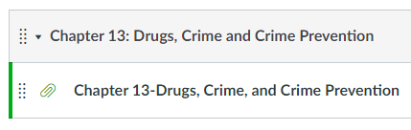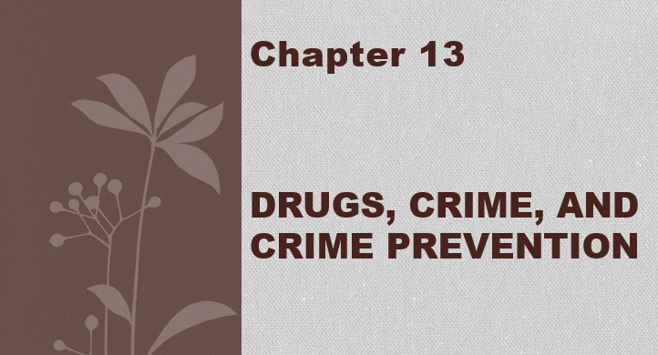

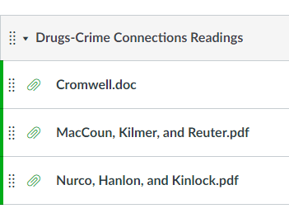
Background:  Color Schemes: Microsoft PowerPoint Opulent  Text Attributes: N/A  Subheading: Microsoft PowerPoint Trebuchet MS (Headings)  Body: Microsoft PowerPoint Berlin Sans FB Demi | Media:  Audio: Narration by Kampe (2021).  Video: TBD  Animated Gifs: TBD  Graphics: TBD
Developer’s Notes: Linked PowerPoint, text documents, and group assignment

Module 14 – The School and Crime Prevention

Course Objective
The student will be able to perform the following tasks:
- Appraise schools and their approaches to crime prevention.

Module 14 Objectives
The student will be able to:
- Define “tracking” and how it relates to delinquency.
- Discuss how altering the school atmosphere can change student behavior.
- Discuss bullying prevention programs and their effectiveness.

Student Activities
M14S1 Lab text, Chapter 14 (The School and Crime Prevention).
M14S2 Module 14 PowerPoint (The School and Crime Prevention).
M14S3 Journal articles.

Assessment Activities
M14A1 Complete the Module 14 Discussion assignment.
M14A2 Group UCF Evaluation assignments and presentations.

Type | # | Resource | Information
Student Activity | 1 | Lab textbook | Students will be asked to read Chapter 14 (The School and Crime Prevention) of their textbook.  Students will learn about the role of schools as agents of secondary crime prevention through discussions of theories that support schools’ attributions to delinquency, aspects of the educational process that are important for delinquency, and the programs that have been established to intervene in schools’ harmful aspects (particularly programs that examine in-school misbehavior).
 | 2 | Module 14 PowerPoint | Students will be asked to review Chapter 14 (The School and Crime Prevention).  This will provide students with a review of the textbook chapter and will point out the most pertinent information from the chapter.
 | 3 | Journal articles | Students will be asked to find and review any additional peer-reviewed journal articles that they feel relate to the information presented in Module 14.
Assessment | 1 | Discussion | Guiding Topic:  Discuss a school intervention that has shown a positive impact on the school environment in terms of reduced misbehavior and delinquency. Use scholarly sources (such as peer-reviewed articles) to support your findings.  Alternative Topic:  Discuss a topic in the readings that you found interesting, confusing, or in need of further discussion.  Guidelines:  Students will be expected to participate in weekly discussions with their peers to show engagement with the course material. This will include both a substantial original post in which they will discuss an aspect of the week’s material that they found interesting, confusing, or in need of further explanation as well as two responses to fellow students. These discussions will be completed by Sunday of each week at 11:59pm.
 | 2 | Group UCF Evaluation assignments and presentations | Topics:  Observe a location on UCF’s campus for at least 30 minutes. Take notes on what you observe. Following your observation, you should consider what examples of lifestyle perspective may be applied. For example, are their ways that people are acting that might be construed as contributing to possible scenarios that might create opportunities for victimization or are their guardianship issues that are being missed by people? Also consider what are the potential chances for crime that you have seen? Also consider the relationships between educations factors and delinquency listed in your text (IQ and delinquency; school practices and delinquency; and victimization and fear in school), and how what you observed is related.  Guidelines:  Prepare a 10-15 page summary of your findings. Include research from scholarly sources that reinforce your conclusions.  Presentations on this assignment should summarize the findings from your paper as well as the research that you found. Also include whether or not you feel as though immediate changes should be implemented in light of your findings. Also include a section on “best practices” for college students that would make them safer on campus based on what you observed.

Project Title: CJE3444  Page Title: Module 14  File Name: CP_Module14_Content (folder)  Date: 11/22/2021 – 11/28/2021  Frame #: 15000 |  | Script:  Module 14: – PowerPoint  Module 14 Discussion – Link  UCF Evaluation Papers and Presentations – Link
Links:  From Course Home: Module 14 – 15100 | Screen Description:  Links to Module 14
Screen Layout:

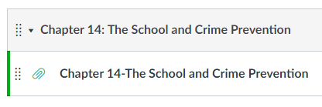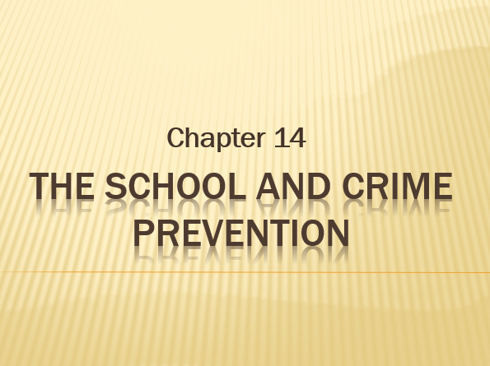

Background:  Color Schemes: Microsoft PowerPoint Trek  Text Attributes: Shadow  Subheading: Microsoft PowerPoint Franklin Gothic Medium (Headings)  Body: Microsoft PowerPoint Franklin Gothic Book (Body) | Media:  Audio: Narration by Kampe (2021).  Video: TBD  Animated Gifs: TBD  Graphics: TBD
Developer’s Notes: Linked PowerPoint and group assignment

Module 15 – Tertiary Crime Prevention

Course Objective
The student will be able to perform the following tasks:
- Discuss different forms of tertiary crime prevention and their effectiveness.

Module 15 Objectives
The student will be able to:
- Discuss specific deterrence and incapacitation.
- Discuss cognitive-behavioral interventions and their effectiveness.
- Provide an overview of the evidence on crime prevention.

Student Activities
M15S1 Lab text, Chapter 15 (Specific Deterrence and Incapacitation).
M15S2 Lab text, Chapter 16 (Rehabilitation).
M15S3 Lab text, Chapter 17 (Some Closing Thoughts on Crime Prevention and the Future).
M15S4 Module 15 PowerPoint (Tertiary Crime Prevention/Closing Thoughts and the Future).
M15S5 Final Exam Review.

Assessment Activities
M15A1 Complete the Module 15 Discussion assignment.
M15A2 Complete Final Exam.

Type | # | Resource | Information
Student Activity | 1 | Lab textbook | Students will be asked to read Chapter 15 (Specific Deterrence and Incapacitation) of their textbook.  This chapter will educate students about two forms of tertiary crime prevention-specific deterrence and incapacitation. The chapter includes definitions for each form of tertiary crime prevention, discussions of their effectiveness, and future implications for their continued use in their present forms.
 | 2 | Lab textbook | Students will be asked to read Chapter 16 (Rehabilitation) of their textbook.  This chapter will provide students with a brief overview of rehabilitation. It will include an examination of the debate on the rehabilitation controversy, discusses the problems inherent in the research and debate, and considers a few promising approaches.
 | 3 | Lab textbook | Students will be asked to read Chapter 17 (Some Closing Thoughts on Crime Prevention and the Future) of their textbook.  This brief chapter offers students some summary comments about crime prevention and points out topics or ideas that had been previously omitted (or only cursorily discussed) from the text.
 | 4 | Module 15 PowerPoint | Students will be asked to review the PowerPoint from Chapter 15 (Specific Deterrence and Incapacitation), Chapter 16 (Rehabilitation), and Chapter 17 (Some Closing Thoughts on Crime Prevention and the Future) titled Tertiary Crime Prevention/Closing Thoughts and the Future.  This will provide students with a review of the textbook chapter and will point out the most pertinent information from the chapter.
 | 5 | Final Exam Review | The exam will be based on class notes, assigned course readings, handouts, class assignments, class discussions, and other required course material.  It is the responsibility of the student to be prepared for all exams by reviewing the material from Chapters 12-17.
Assessment | 1 | Discussion | Guiding Topic (Choose one):  - Provide information about the effectiveness of electronic monitoring to reduce recidivism and other effects.  - Provide arguments for each side of the “nothing works” debate.  - Identify problems within evaluations of crime prevention that should be addressed in future analyses.  Alternative Topic:  Discuss a topic in the readings that you found interesting, confusing, or in need of further discussion.  Guidelines:  Students will be expected to participate in weekly discussions with their peers to show engagement with the course material. This will include both a substantial original post in which they will discuss an aspect of the week’s material that they found interesting, confusing, or in need of further explanation as well as two responses to fellow students. These discussions will be completed by Sunday of each week at 11:59pm.
 | 2 | Final Exam | The Final Exam can be found under the “Exams” tab in Webcourses.  Guidelines:  Exams will be 50 questions in the format of multiple choice and true/false. Students will have 75 minutes from the time that they open the exam to answer all questions and submit their responses. Should a student not complete all 50 questions in the time provided, the exam will automatically be submitted by Webcourses with the answers that have been given by the student. Unanswered questions will be graded as incorrect.  All exams must be taken before the test closing date. No makeup exams will be given without the prior, explicit approval of the instructor or a documented emergency. Should a student miss an exam, it is the responsibility of the student to make arrangements with the instructor to make up that exam.

Project Title: CJE3444  Page Title: Module 15  File Name: CP_Module15_Content (folder)  Date: 11/29/2021 – 12/5/2021  Frame #: 16000 |  | Script:  Module 15: Tertiary Crime Prevention/Closing Thoughts and the Future – PowerPoint  Module 15 Discussion – Link  Final Exam Review – Text document  Final Exam – Quiz
Links:  From Course Home: Module 15 – 16100 | Screen Description:  Links to Module 15
Screen Layout:

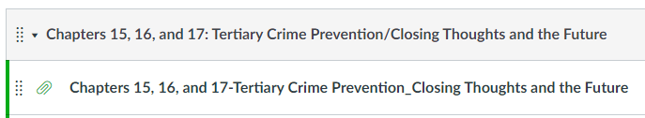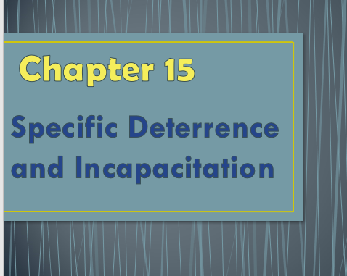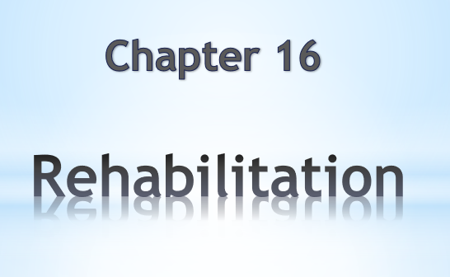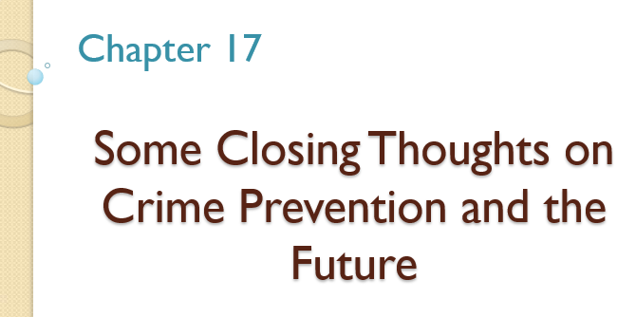
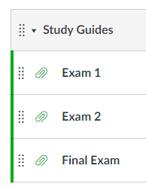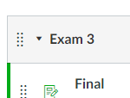

Background:  Color Schemes: Microsoft PowerPoint Thatch, Slipstream, and Solstice  Text Attributes: Shadow  Subheading: Microsoft PowerPoint Berlin Sans FB Demi, Trebuchet MS (Headings), and Gill Sans MT (Headings)  Body: Microsoft PowerPoint Tw Cen MT (Body), Trebuchet MS (Body), and Gill Sans MT (Headings) | Media:  Audio: Narration by Kampe (2021).  Video: TBD  Animated Gifs: TBD  Graphics: TBD
Developer’s Notes: Linked PowerPoint, text document, and quiz

